Part list

S. No. | Part | Quantity | Image
1. | Chassis | 1 | 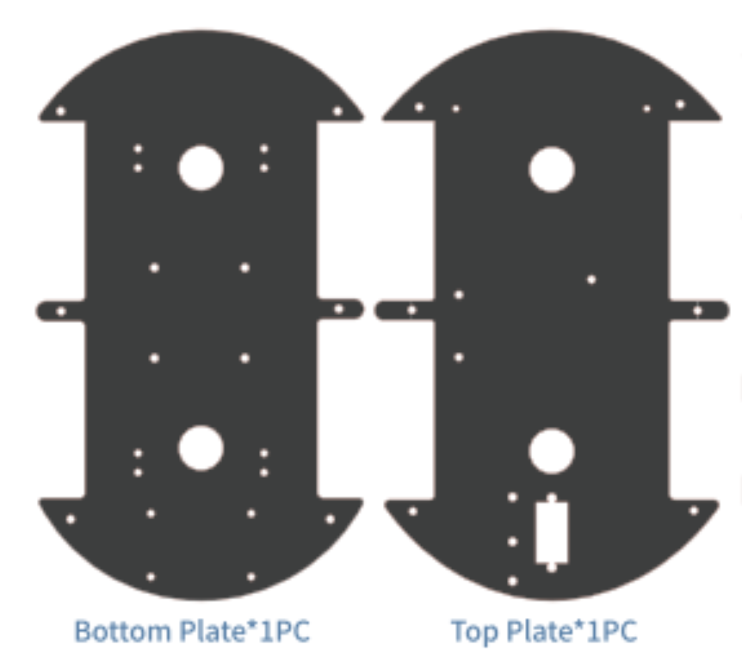
3. | Arduino uno board | 1 | 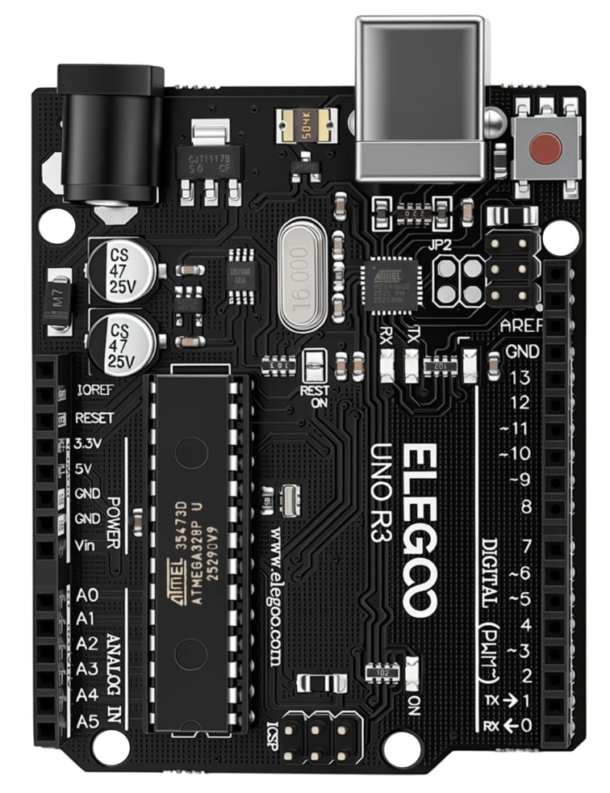
4. | Motor Controller | 1 | 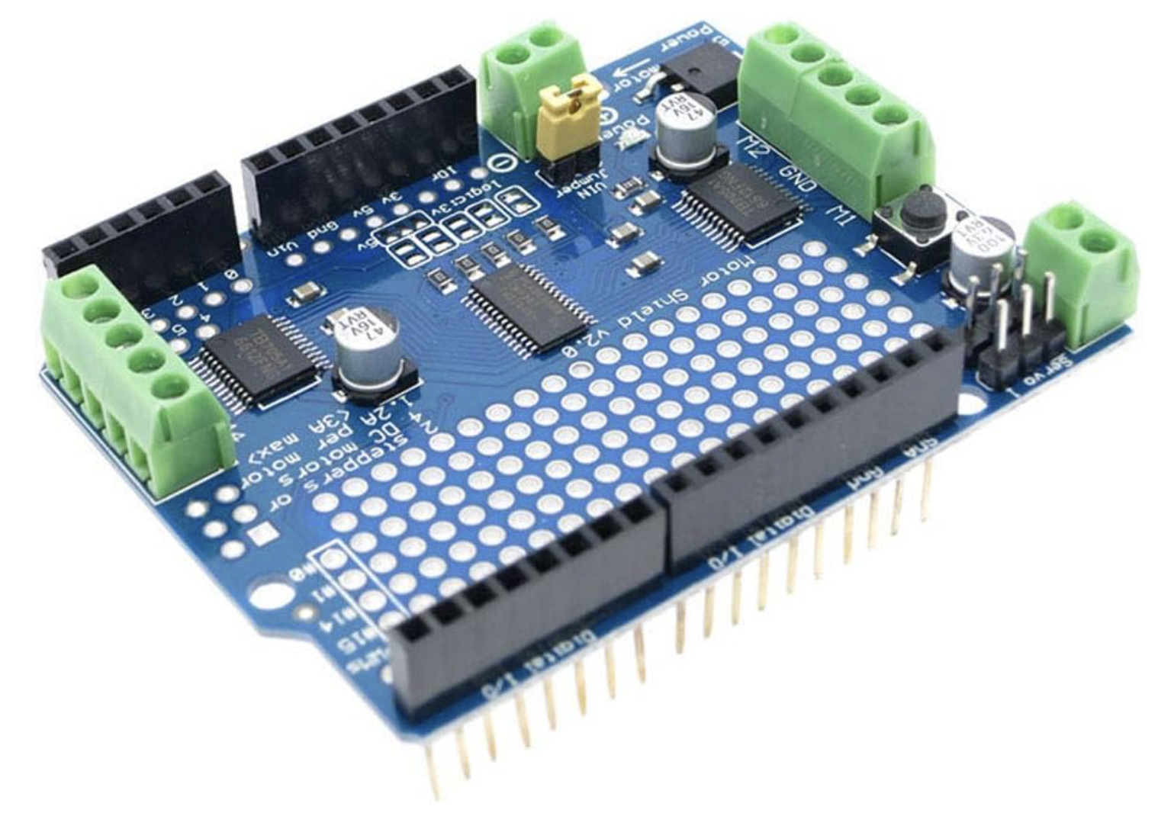
5. | Motors and wheels | 4 | 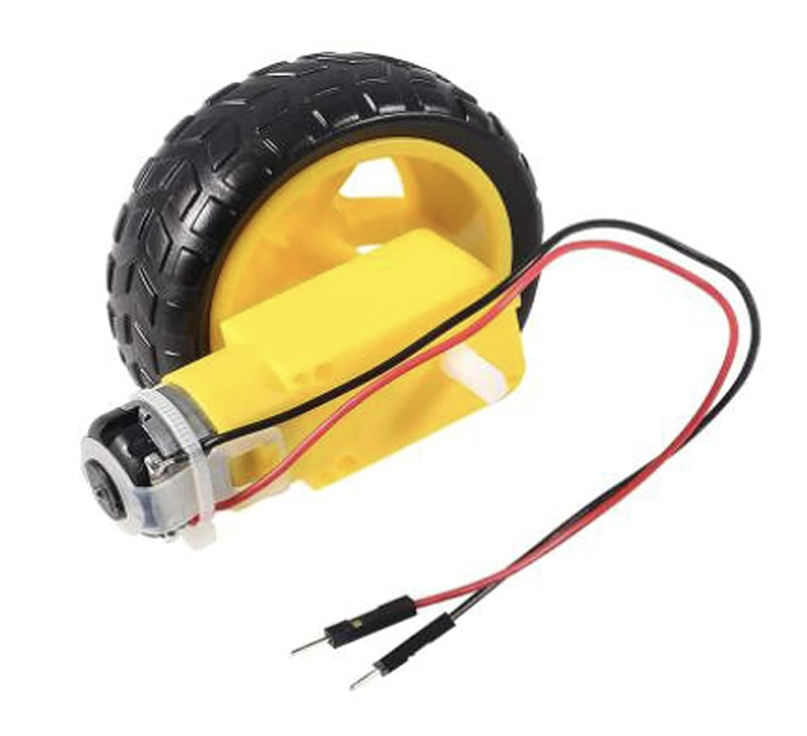
6. | Photoresistors | 4 | 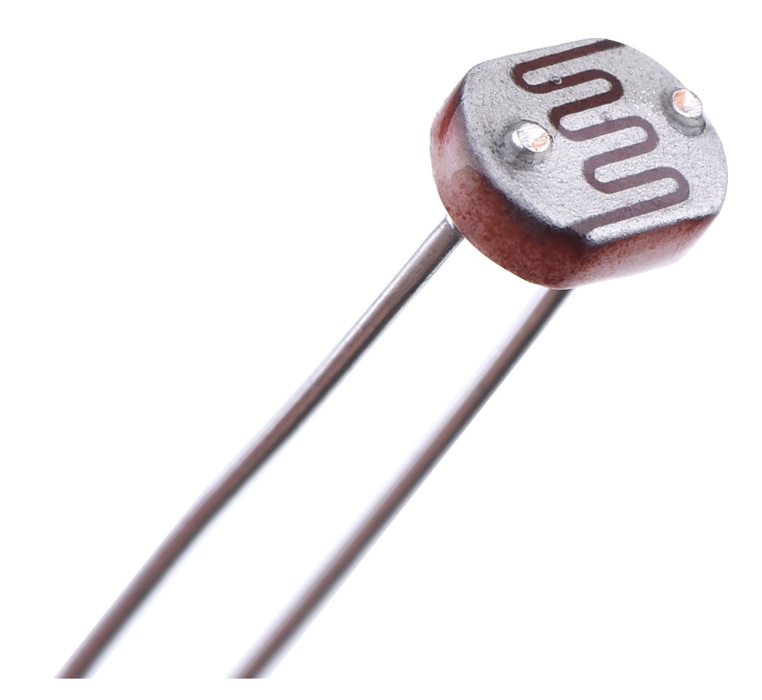
7. | Small PCB | 1 | 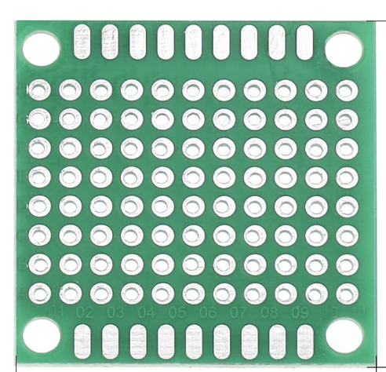
8. | Battery holder | 1 | 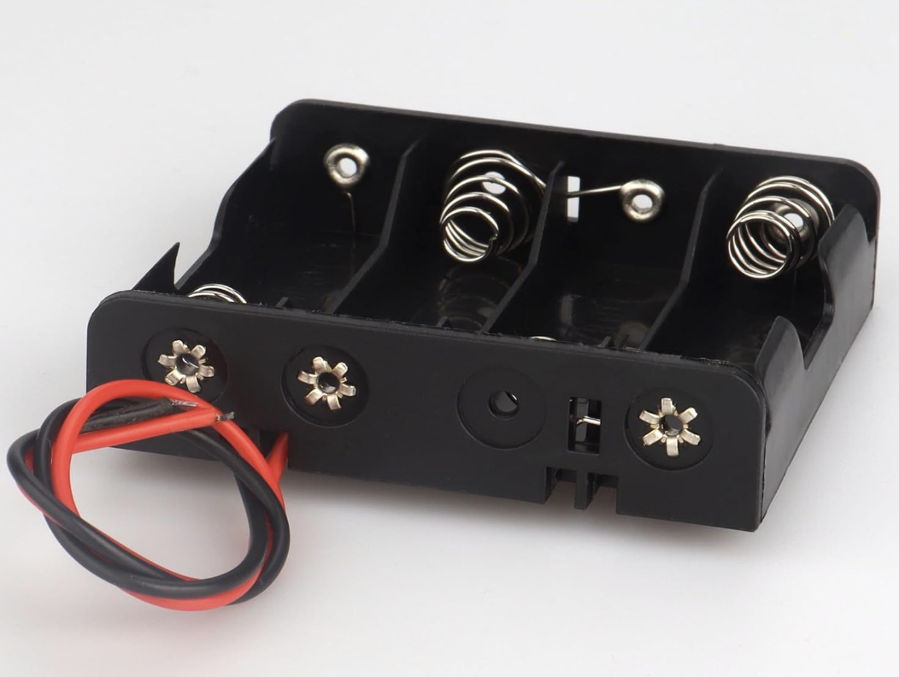
9. | 10 kΩ resistors | 4
10 | Breadboard | 1 | 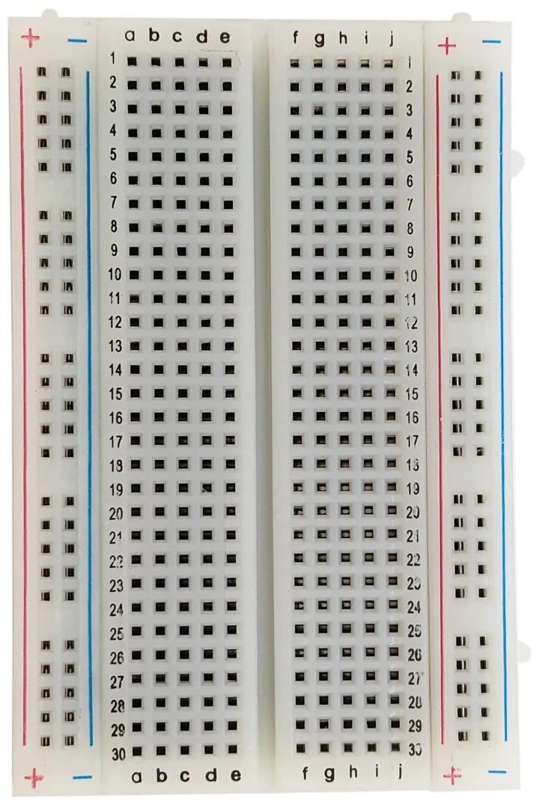
11. | Miscellaneous (Jumper cables, screws, nuts, bolts, resistors, etc.) | Multiple

Instructions/Steps
- Assemble and test the basic chassis + motor setup
  - Assemble the motors+wheel assembly on the chassis
  - Mount the arduino board to the chassis
  - Connect the motor driver to the arduino and the motors to the motor driver.
  - Connect the power source to the arduino and the motor driver
  - Program and test the basic motor functionality, e.g. if we can make the robot go forward/backwards, turn both sides etc.
- Assemble and test the light direction sensor
  - Connect the photoresistors to create the light sensor assembly as shown below (we will 3D print the separator). This is just a schematic, and the actual design might be different
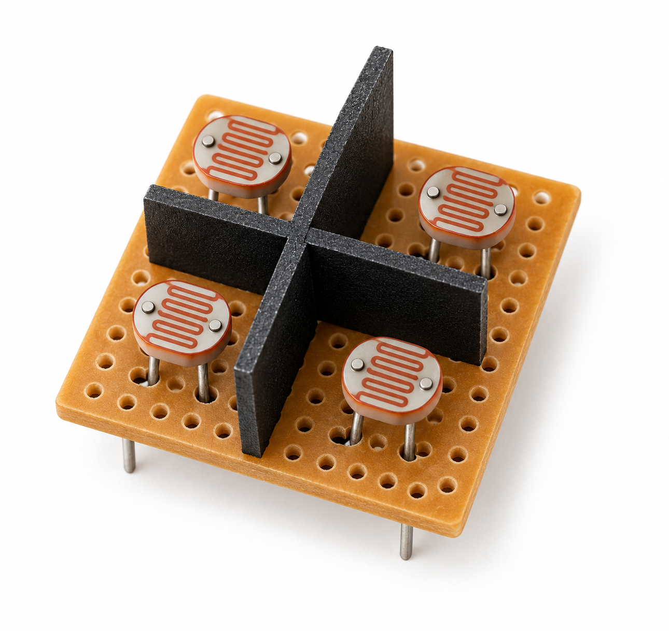
  - Connect the sensor assembly to the arduino board and test basic functionality, e.g. is it able to detect the direction of the light source reliably. Calibrate the light conditions etc. as needed.
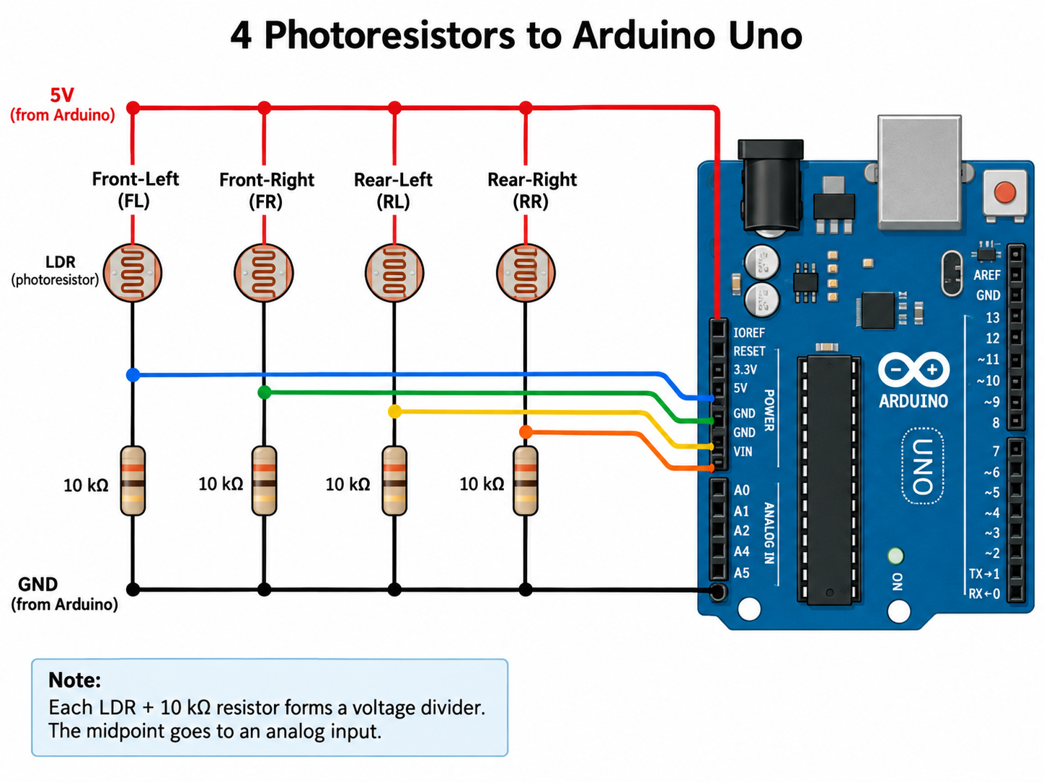
- Put it all together and test
  - Mount the light sensor on the top of the robot and connect it to the arduino board
  - Program the board to move in the direction of light
  - Test if the robot is able to move towards the light source in various directions and distance settings

